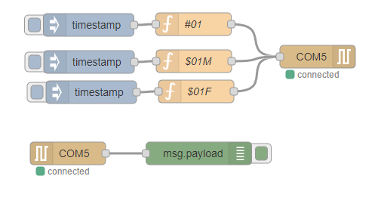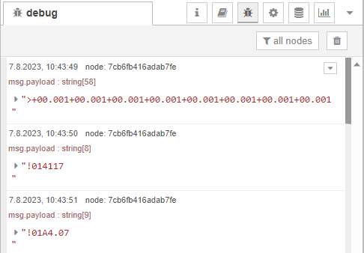
[{"id":"eaf183be03a79463","type":"inject","z":"e23aec5fe63f0179","name":"","props":[{"p":"payload"},{"p":"topic","vt":"str"}],"repeat":"","crontab":"","once":false,"onceDelay":0.1,"topic":"","payloadType":"date","x":172.5,"y":193,"wires":[["5239e8e737f62dd4"]]},{"id":"7cb6fb416adab7fe","type":"debug","z":"e23aec5fe63f0179","name":"","active":true,"tosidebar":true,"console":false,"tostatus":false,"complete":"false","statusVal":"","statusType":"auto","x":318.5,"y":363,"wires":[]},{"id":"5239e8e737f62dd4","type":"function","z":"e23aec5fe63f0179","name":"#01","func":"msg.payload = (\"#01\" + \"\\r\");\nreturn msg;","outputs":1,"noerr":0,"initialize":"","finalize":"","libs":[],"x":311.5,"y":192,"wires":[["f74952b4e73a05bd"]]},{"id":"af11719b14fbaa8b","type":"serial in","z":"e23aec5fe63f0179","name":"","serial":"b791d0729b61f2ca","x":145,"y":363,"wires":[["7cb6fb416adab7fe"]]},{"id":"f74952b4e73a05bd","type":"serial out","z":"e23aec5fe63f0179","name":"","serial":"b791d0729b61f2ca","x":476,"y":235,"wires":[]},{"id":"29b8236da3849f99","type":"inject","z":"e23aec5fe63f0179","name":"","props":[{"p":"payload"},{"p":"topic","vt":"str"}],"repeat":"","crontab":"","once":false,"onceDelay":0.1,"topic":"","payloadType":"date","x":173,"y":242,"wires":[["38da20bfc14814ae"]]},{"id":"38da20bfc14814ae","type":"function","z":"e23aec5fe63f0179","name":"$01M","func":"msg.payload = (\"$01M\" + \"\\r\");\nreturn msg;","outputs":1,"noerr":0,"initialize":"","finalize":"","libs":[],"x":312,"y":241,"wires":[["f74952b4e73a05bd"]]},{"id":"c84fa1487053ef46","type":"inject","z":"e23aec5fe63f0179","name":"","props":[{"p":"payload"},{"p":"topic","vt":"str"}],"repeat":"","crontab":"","once":false,"onceDelay":0.1,"topic":"","payloadType":"date","x":176,"y":282,"wires":[["3e3b9b8a13e6dc75"]]},{"id":"3e3b9b8a13e6dc75","type":"function","z":"e23aec5fe63f0179","name":"$01F","func":"msg.payload = (\"$01F\" + \"\\r\");\nreturn msg;","outputs":1,"noerr":0,"initialize":"","finalize":"","libs":[],"x":315,"y":281,"wires":[["f74952b4e73a05bd"]]},{"id":"b791d0729b61f2ca","type":"serial-port","serialport":"COM5","serialbaud":"9600","databits":"8","parity":"none","stopbits":"1","waitfor":"","dtr":"none","rts":"none","cts":"none","dsr":"none","newline":"\\r","bin":"false","out":"char","addchar":"","responsetimeout":"10000"}]
